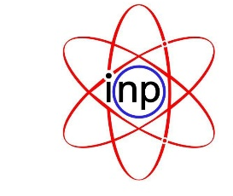
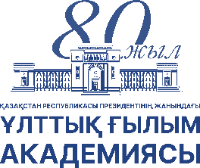
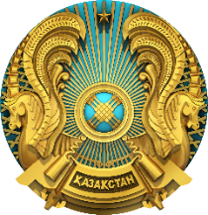
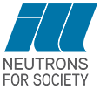

Scientific and Practical Workshop
The Institut Laue-Langevin Research Reactor and Neutron Facilities:
International Opportunities for Research in the Scientific and Industrial Sectors
of the Republic of Kazakhstan
May 25-28, 2026 · National Academy of Sciences of the RK, 28 Shevchenko str., Almaty

organised by
 | ARKAE  Agency of the Republic of Kazakhstan for Atomic Energy |  | NAS RK  National Academy of Sciences of the Republic of Kazakhstan |  | INP  Institute of Nuclear Physics ARKAE |  | ILL  Institut Laue-Langevin, Grenoble, France

Event | Time | Presenter / Participants
May 25 — Monday | NAS RK, 28 Shevchenko str., Big Hall
Registration of participants | 12:00 – 13:00
Opening of the Workshop.  Welcome speech by the organizers | 13:00 – 13:30 | А. Satkaliyev · А. Kurishbayev  S. Sakhiyev · К. Andersen
Institut Laue-Langevin – institutional presentation | 13:30 – 14:30 | Кen Andersen
Coffee break | 14:30 – 14:45
Diffraction @ ILL: Technical & Scientific Capabilities | 14:45 – 16:00 | Thomas Hansen
Large Scale Structures: Technical & Scientific Capabilities | 16:00 – 17:15 | Philipp Gutfreund
May 26 — Tuesday | NAS RK, 28 Shevchenko str., Big Hall
Spectroscopy @ ILL: Technical & Scientific Capabilities | 09:00 – 10:15 | Paul Steffens
Coffee break | 10:15 – 10:30
Applied Science @ ILL: Technical & Scientific Capabilities | 10:30 – 11:45 | Markus Strobl
Lunch | 11:45 – 13:00
Nuclear and Particle Physics: Technical & Scientific Capabilities | 13:00 – 14:15 | Michael Jentschel,  Valery Nesvizhevsky
Support services for cutting-edge science at ILL | 14:15 – 15:15 | Jacques Jestin
Coffee break | 15:15 – 15:30
Applying for beam time at ILL by researchers in Kazakhstan | 15:30 – 16:30 | Mark Johnson
Industry access to beam time at ILL | 16:30 – 17:00
May 27 — Wednesday | INP site, 1 Ibragimova str.
Technical tour to the INP facilities  - WWR-K Research Reactor: Main hall · Radiography installation · Reflectometry installation Neutron activation analysis · Critical assembly  - Materials science | 09:00 – 12:00 | All participants
Lunch | 12:00 – 13:30
Cultural program | 13:30 – 18:00 | All participants
May 28 — Thursday | NAS RK, 28 Shevchenko str., Big Hall
From Waste to Energy and Clean Water: Advanced Materials Approach | 09:00 – 09:30 | Dr. Prof. Seitkhan Azat,  Satbayev University
Modern laboratory solutions in mining & metallurgy: experience of East Kazakhstan Technical University | 09:30 – 10:00 | Dr. Yernat Kozhakhmetov,  East Kazakhstan State Technical University
Use of (fast) neutrons for development of rice germplasm adapted to extreme conditions of the Kazakh Aral Sea region | 10:00 – 10:30 | Dr. Nurbol Appazov,  Korkyt Ata Kyzylorda State University
Coffee break | 10:30 – 10:45
International Experimental Capabilities of ILL for Study and Verification of Materials within the VCN and UCN Sources Project in RK | 10:45 – 11:15 | Dr. Kylyshbek Turlybekuly,  INP
Mechanism of anomalous thermal expansion of irradiated Be12Ti during evolution of helium-vacancy complexes | 11:15 – 11:45 | Timur Erlanov,  Laboratory of Applied and Theoretical Materials Science  INP
Lunch | 11:45 – 13:00
Neutron instruments on the beams of the WWR-K reactor | 13:00 – 13:30 | Kuanysh Nazarov,  Laboratory of Neutron Physics, INP
WWR-K research reactor as a center for testing nuclear and structural materials | 13:30 – 14:00 | Asset Shaimerdenov,  Laboratory of Atomic Energy Safety Problems, INP
Coffee break | 14:00 – 14:30
Workshop Summary & Closing | 14:30 – 15:00 | All participants
May 28 — Closed Session (Management) | Eastern Hall
Roundtable: Discussion of Kazakhstan's participation in the ILL user program for research | 15:00 – 17:00 | Management

