**Cluster structure of light nuclei and its influence on mechanism of low energy nuclear reactions**

**Author:** Viacheslav Samarin1

**Co-author:** Anton Bazhin2

1*Joint Institute for Nuclear Research, Dubna, Russia*

2*Dubna State University, Dubna, Russia*

**Corresponding Author:** samarin@jinr.ru

The structure of the light nuclei 6Li, 9,10,11,12Be, 10,11B, 12,13,14C, 13,14N and 14O were studied using the alpha-cluster model with hyperspherical functions and Feynman’s path integrals [1‒4] and the shell model of the deformed nuclei [5]. Results for the 12C and 9Be nuclei are shown in Figs. 1, 2.

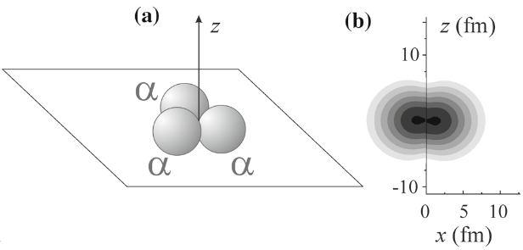

Fig. 1. The regular triangle configuration in the alpha-cluster models (**a**) and the total neutrons probability density (logarithmic scale) for the 12C nucleus obtained in the shell model of a deformed nucleus (**b**)

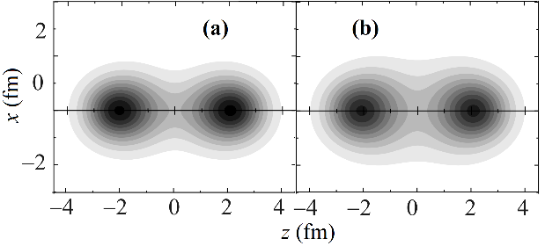

Fig. 2. The total protons (**a**) and neutrons (**b**) probability densities (linear scale) for the 9Be nucleus obtained in the shell model of a deformed nucleus

The cluster transfer channels in the low energies nuclear reactions [6, 7] are explained taking into account the cluster structure of the 9Be nucleus.

References:

1. Samarin, V.V., Study of spatial structures in *α*-cluster nuclei, Eur. Phys. J. A, **58**, 117 (2022).

2. Bazhin A. S. and Samarin V. V., Study of the Structure of the 9Be Nucleus in the Alpha-Cluster Model by the Method of Hyperspherical Functions, Bull. Russ. Acad. Sci.: Phys. **88**, 1177 (2024).

3. Samarin V. V., Studying the Ground States of 13, 14C, 13, 14N and 14O Nuclei with Feynman’s Continual Integrals, Bull. Russ. Acad. Sci.: Phys., **86**, 901 (2022).

4. Samarin V. V., Studying the Ground States of 10,11B, 10,11С Nuclei Using Feynman’s Continual Integrals, Bull. Russ. Acad. Sci.: Phys., **85**, 501 (2021).

5. Samarin V.V., Description of Nucleon-Transfer and Fusion Reactions within Time-Dependent Approaches and Coupled-Channel Method, Phys. Atom. Nucl. **78**, 128 (2015).

6. Lukyanov S.M., Harakeh M.N., Naumenko, M.A., *et al*., Some Insights into Cluster Structure of 9Be from 3He + 9Be Reaction, World J. Nucl. Sci. Technol., **5**, 265 (2015).

7. Urazbekov B. A., Issatayev T., Lukyanov S. M., Azhibekov A., *et al*., Reactions induced by 30 MeV 3He beam on 9Be: cluster transfer reactions, Chinese Physics C, **48**, 014001 (2024).

**Section**:

Nuclear physics (Section 1)