**Application of coordinate-sensitive detectors based on microchannel plates in a time-of-flight spectrometer**

D. Aznabayev a,b 1, T. Issatayev a,b, V.I. Smirnov a

*a) Joint institute for nuclear research, Dubna, Russia*

*b) Institute of nuclear physics, Almaty, Kazakhstan*

email: daur_is101@jinr.ru

Results from reaction product measurements using a time-of-flight spectrometer with a coordinate-sensitive detector based on microchannel plates [1-3] are presented. The advantages of these MCP include their high positional sensitivity, good time resolution, and high efficiency in registering heavy charged particles with low energy. This work provides a technical description of the fission fragment registration system and the results of measurements of the parameters of the coordinate-sensitive detector obtained during the measurement of spontaneous fission fragments of 252Cf, as well as during the registration of 14N+197Au at the MAVR facility. The results are of significant interest for the study of mechanisms of heavy nuclei fission and provide valuable data for theoretical research in nuclear physics. The use of such detector systems can lead to interesting results in experiments aimed at determining the masses of nuclear reaction products and reconstructing particle trajectories. Future research will involve other nuclear reactions such as 40Ar+197Au, 238U, 136Xe+197Au, 238U.

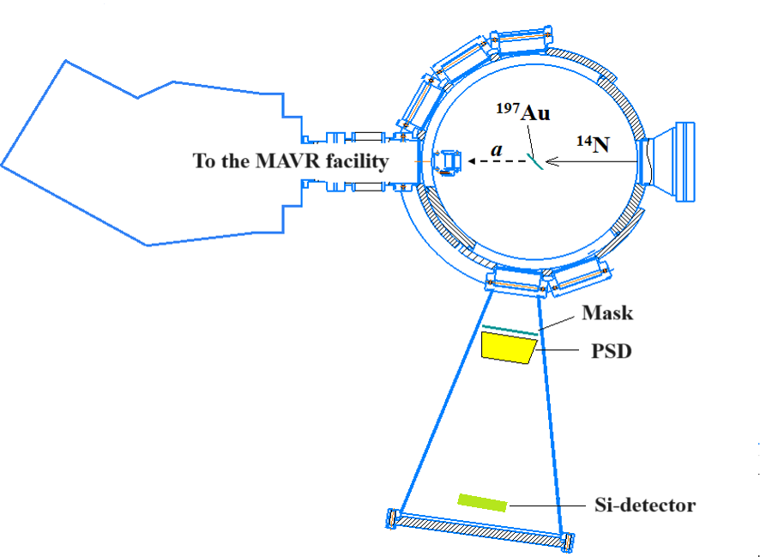

*Fig. 1. Schematic of the time-of-flight spectrometer connected to the reaction chamber.*

**Literature:**

1. V.D. Dmitriev, S.M. Lukyanov, Yu.E. Penionzhkevich, D.K. Sattarov. Microchannel Plates in Experimental Nuclear Physics // PTE. 1982. No. 2, pp. 7-18.

2. D. Aznabaev, V.I. Smirnov, A. Isatov, K. Mendibaev, T. Isataev. Measurement of the Time of Flight of Charged Particles with a Microchannel Plate-Based Timing Detector for the MAVR Setup // Letters in EPJA. 2019. Vol. 16, No. 6(225). pp. 620-626.

3. V.A. Maslov, V.I. Kazacha, I.V. Kolesov, S.M. Lukyanov, V.N. Melnikov, N.F. Osipov, Yu.E. Penionzhkevich, N.K. Skobelev, Yu.G. Sobolev, E.I. Voskoboinik. High-resolution Magnetic Analyzer MAVR for the Study of Exotic Weakly Bound Nuclei, Proceedings of IASEN. 2013. World Scientific, p. 103-109.