|  |
| --- |
| Measurement of the Standard Model at the TeV colliders |
| Eldor Eshobobo ugli Dustmurodov1,2, Mavjuda Yuldashevna Mansurova1, Gulnoza Sultankhodjaeva1, Gulnora Kasimova1 |
| 1 Tashkent State University of Transport, Tashkent, Uzbekistan  *2 Institute of Nuclear Physics, Uzbekistan Academy of Sciences, Tashkent, Uzbekistan*  [eldordustmurodov@mail.ru](mailto:eldordustmurodov@mail.ru) |

Keywords: Parton Distribution Functions (PDF), pA - proton-nucleus, QCD - Quantum Chromodynamics, NLO - Next-to-Leading Order transverse cross section.

Annotation: We have studied that the LHC data for Standard Model (SM) processes cover a very wide kinematic range, providing access to transverse momenta and masses of the order of TeV and above. For an accurate understanding at such scales, it is necessary to consider higher-order electroweak (EW) corrections in addition to QCD corrections. SM data obtained at 7 TeV and 8 TeV, with their small statistical uncertainties and decreasing (over time) systematic errors, are useful not only for testing theoretical predictions but also as input data for the global parton distribution function (PDF).

# Introduction

Among various mechanisms for the production of the Higgs boson (H) within the framework of the Standard Model, gluon-gluon fusion (GGF) through a virtual loop of top quarks has the largest cross-section at the Large Hadron Collider (LHC). Although direct measurements of the properties of the Higgs boson in this channel, without imposing any constraints on additional jets, are challenging due to the large QCD background, precise theoretical predictions for associated Higgs boson production and jets in GGF are important for several reasons. On one hand, the ability to reliably estimate theoretical uncertainty when applying jet veto largely depends on the knowledge of inclusive and exclusive cross-sections for Higgs boson production and additional jets. On the other hand, Higgs boson production together with two jets in GGF is one of the main irreducible backgrounds for studying the Higgs boson formation via vector boson fusion (VBF), which allows for direct exploration of the Higgs boson's connection with other electroweak bosons.

The contribution of leading order (LO) in Higgs boson production combined with two jets (H+2-jets) and three jets (H+3-jets), while preserving the full dependence on the top quark mass (mt), has been computed accordingly in the references. These calculations have shown that the large top mass approximation (mt → ∞) holds whenever the mass of the Higgs boson and the transverse momentum (pT) of the jets are only slightly larger than the top quark mass. In the results presented here, we adopt this approximation and introduce a set of effective vertices that directly couple the Higgs boson to two, three, and four gluons.

# Results

Results. We begin our discussion by presenting several predictions for the distribution of the Higgs boson velocity in Fig. 1. In all three panels of this figure, we show the same NLO prediction for H+3-jets production (red lines) and compare it on the two left panels with two different LO precision predictions for H+3-jets (blue lines). We observe large, O(50%), positive corrections distributed almost uniformly across the entire range of Higgs velocity; they increase in the forward/backward region. On the far-left panel, both LO and NLO predictions were obtained from the same set of NLO PDFs, namely CT10nlo. As seen on the middle panel, corrections decrease by ∼20% if a prescription is used that agrees between PDF sets and parton-level calculations. Then, half of the effect can simply be attributed to the larger value of as(MZ) in the cteq6l1 parametrization, which we used to compute the LO result in the middle panel. The scale uncertainties of central predictions are shown by corresponding bands of the same color. 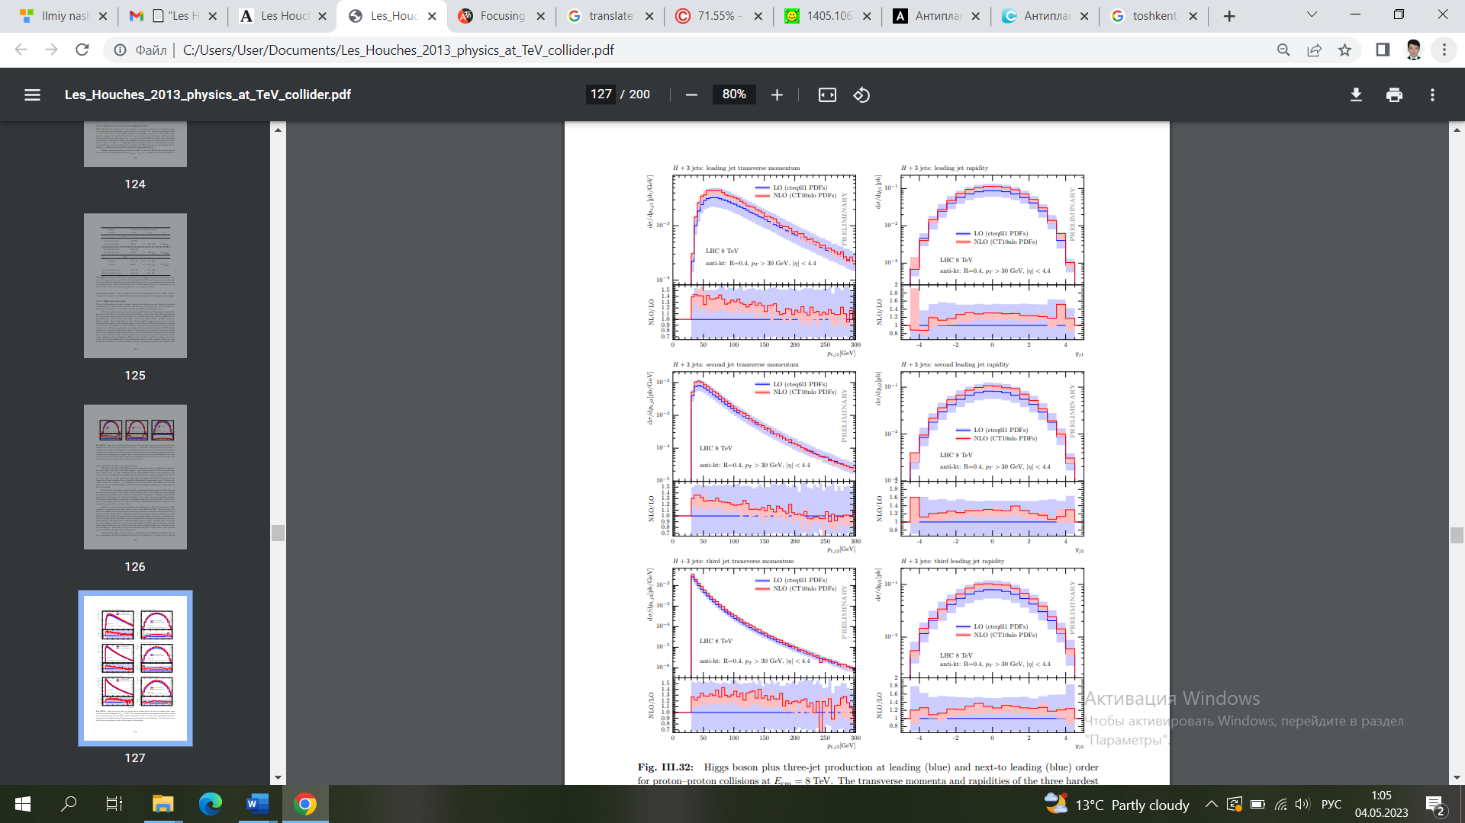By advancing the description accuracy to NLO, we find a reduction of these errors from ±50% to less than 30% in magnitude, which also means that scale variation bands go from quite symmetric to rather one-sided.

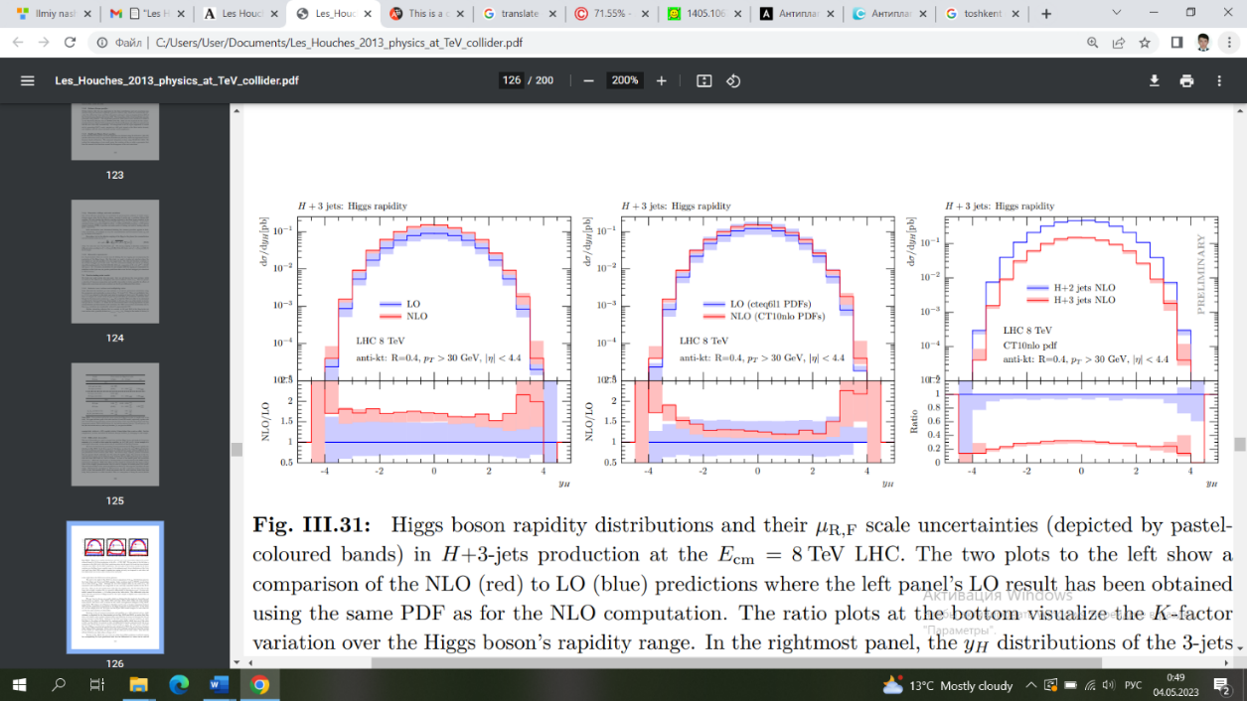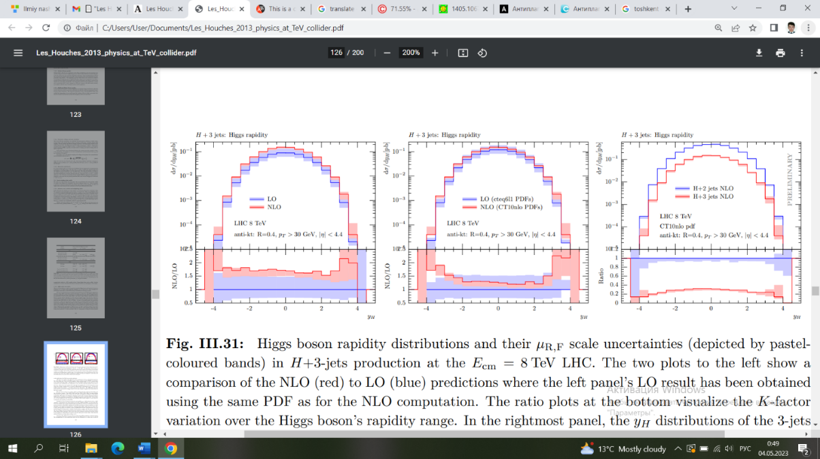 This is a consequence of setting the central/default scales precisely where the plateau of the NLO cross-section lies.

Figure 1: Distributions of Higgs boson velocities and their uncertainties in the scale of µR,F (shown by pastel-colored bands) for H+3-jets production at the LHC with a center-of-mass energy of 8 TeV. The two left plots show the comparison of NLO (red) and LO (blue) predictions, where the LO result on the left panel was obtained using the same PDF set as for the NLO calculation. The ratio plots at the bottom visualize the change in the K-factor across the range of Higgs boson velocities. The rightmost panel compares the distributions of yH for NLO samples with 3 jets (red) and 2 jets (blue) (only two tagging jets are required), while the bottom part shows their differential cross-section ratio.

The plot to the right of Fig. 1 represents a direct comparison of the distributions of yH obtained in the NLO samples with 2 jets (blue) and 3 jets (red). Scale fluctuations lead to O(20%) uncertainties over a fairly wide range of yH. Although the two NLO samples differ by an order of as, the associated scale uncertainties are comparable in size and only slightly smaller for the case of H+2-jets. Since we require no more than two tagging jets, the H+3-jets line on the bottom plot effectively visualizes the quantity r3/2 differently depending on yH. It varies slightly within the inclusively -0.3 value provided in the table above. The differential ratio also shows that Higgs boson production in the 3-jets sample occupies a somewhat more central position than in the 2-jets sample.

Figure 2: Higgs boson plus three-jet production in the leading (blue) and next-to-leading (green) orders for proton-proton collisions at Ecm = 8 TeV. Transverse momenta and velocities of the three leading jets are shown in the left and right columns, respectively. The scale uncertainties have been indicated by slightly shaded bands surrounding each central prediction. The bottom plots depict variations in the K-factor for each of these observed individual jets.

Focusing on the transverse momenta and velocities of jets pT,j (left columns) and yj (right columns), as shown for the three leading jets in Fig. 2, we notice that they demonstrate very similar scale variation characteristics and error reduction as discussed for the yH spectra presented in Fig. 1. Similarly, for the NLO corrections on jet velocities, we again find that they are fairly well described by constant positive shifts, which here amount to approximately 20%, see Fig. 2. In contrast, all differential K-factors associated with the pT distributions in jets on this plot exhibit a decrease towards higher pT values. In other words, even though the velocity of the Higgs-associated jet formation increases at NLO, pT tails lose hardness when taking relative measures. This occurs due to additional radiation carried away by the fourth jet system, which shifts the spectra of all other jets towards lower values[4].

**Conculusion**

Utilizing recent advancements in automated NLO prediction calculations, we have reported on the results of NLO QCD in a similar ATLAS analysis of inclusive Higgs boson plus 2-jet and 3-jet final states.

Amplitudes for loop calculations were generated using GoSam and computed using new developments in methods for reducing sub-integral expressions, based on Laurent series expansion and implemented in the Ninja code. For the integration of amplitudes at tree-level and phase space, we utilized Sherpa and MadGraph/Dipole/Event framework.

We believe that NLO corrections are significant and lead to a substantial change in jet velocity and hardness. At the level of the inclusive cross-section, we observe an increase of almost 30% for both H+2-jets and H+3-jets, while the scale variation decreases to approximately 15%. Looking at the differential distributions, we observe that the velocity distributions for the Higgs boson and the first three leading jets experience a positive shift of approximately 20%, which remains fairly constant across the entire kinematic range. Instead, for the transverse momentum distributions of jets, we observe a decrease in the K-factor towards higher pT values, while for the transverse momentum distribution of the Higgs boson, this decrease occurs very slowly. The differential ratios r3/2 for velocities are quite flat and never exceed 35%, but for transverse momentum distributions, they reach 50% for the leading jet and the Higgs boson. This shows that the contribution of H+3-jets cannot be neglected in inclusive analyses sensitive to two jets. Another observable in which NLO corrections to H+3-jets play an important role is the pT distribution in the Hj1j2 system. In fact, for the first time, the distribution is described with NLO accuracy for pT > 2pTmin(jet) = 60 GeV.

It would be interesting to study the impact of the NLO corrections presented here when typical VBF cuts are applied. Modern Monte Carlo tools also allow for investigating these corrections in a consistent NLO plus parton shower framework, combined with predictions of lower multiplicities. We defer these investigations to a future publication.

**LITERATURES**

1. G. Soyez, Physics at TeV colliders: standard model working group report// High Energy Physics – Phenomenology, - 2014, vol.1, pp.1405-1607
2. Э.Э Дустмуродов, ОБРАЗОВАНИЕ ЧАСТИЦ ПРИ РЕЛЯТИВИСТСКОМ СТОЛКНОВЕНИИ ТЯЖЕЛЫХ ЯДЕР НА LHC (С ПОМОЩЬЮ GEANT4), Science and Education, toml (9) c.59-65 (2020)
3. Э.Э Дустмуродов, РОЖДЕНИЕ БЫСТРЫХ П0-МЕЗОНОВ В ЯДРО­ЯДЕРНЫХ ВЗАИМОДЕЙСТВИЯХ ПРИ 4, 5 А ГэВ/с С РАСЧЁТАМИ ПО МОДЕЛИ FRITIOF, Science and Education, toml (4) c.11-15 (2020)
4. Б.С Юлдашев, Э.Э Дустмуродов, ПОНИМАНИЕ БОЗОНА ХИГГСА С ПОМОЩЬЮ LheC, Science and Education, toml (4) c.16-21 (2020)
5. Дустмуродов Э. Э., Махмудова Д. Х., Юркевич Н. П. Образование частиц при релятивистском столкновении тяжелых ядер на LHC с помощью GEANT4. – 2023.
6. Dustmurodov E., Yavkacheva Z., Maxmudova D. ИЗМЕРЕНИЕ СТАНДАРТНОЙ МОДЕЛИ НА ТЭВ-КОЛЛАЙДЕРАХ //Modern Science and Research. – 2024. – Т. 3. – №. 1. – С. 1-4.