**SURFACE-MODIFIED CARBON NANOTUBES FOR BIOMEDICAL APPLICATIONS**

*Khaydarov R.R.1, Gapurova O.U.1, Garipov I.T.1, Praveen Thaggikuppe Krishnamurthy 2*

1Institute of Nuclear Physics, Tashkent, Uzbekistan

2Department of Pharmacology, JSS Academy of Higher Education & Research, Tamil Nadu, India

Cancer chemotherapeutics (such as Paclitaxel) fail to treat Non-small cell lung cancer (NSCLC), due to limitations such as multidrug resistance, dose limiting toxicities, tumor relapse, off-target side effects and their inability to silence the overexpressed oncogenes. In NSCLC, overexpressed antiapoptotic survivin gene is responsible for promoting NSCLC survival. CD133, a transmembrane glycoprotein, is reported to be overexpressed in NSCLC, it is therefore, can be exploited for site specific drug cargo delivery by using CD133 monoclonal antibody (mAbs) Further, CD133 blockade with mAbs can also help in decreasing NSCLC chemoresistance, carcinogenesis, survival, metastasis and tumor growth.

In 2021-2023, the Uzbek-Indian joint project No. UZB-Ind-2021-77 "CD133 mAbs surface modified carbon nanotubes loaded with Survivin siRNA and Paclitaxel for the treatment of non-small cell lung cancer" [1-3] was executed in the Institute of Nuclear Physics of the Academy of Sciences of the Republic of Uzbekistan.

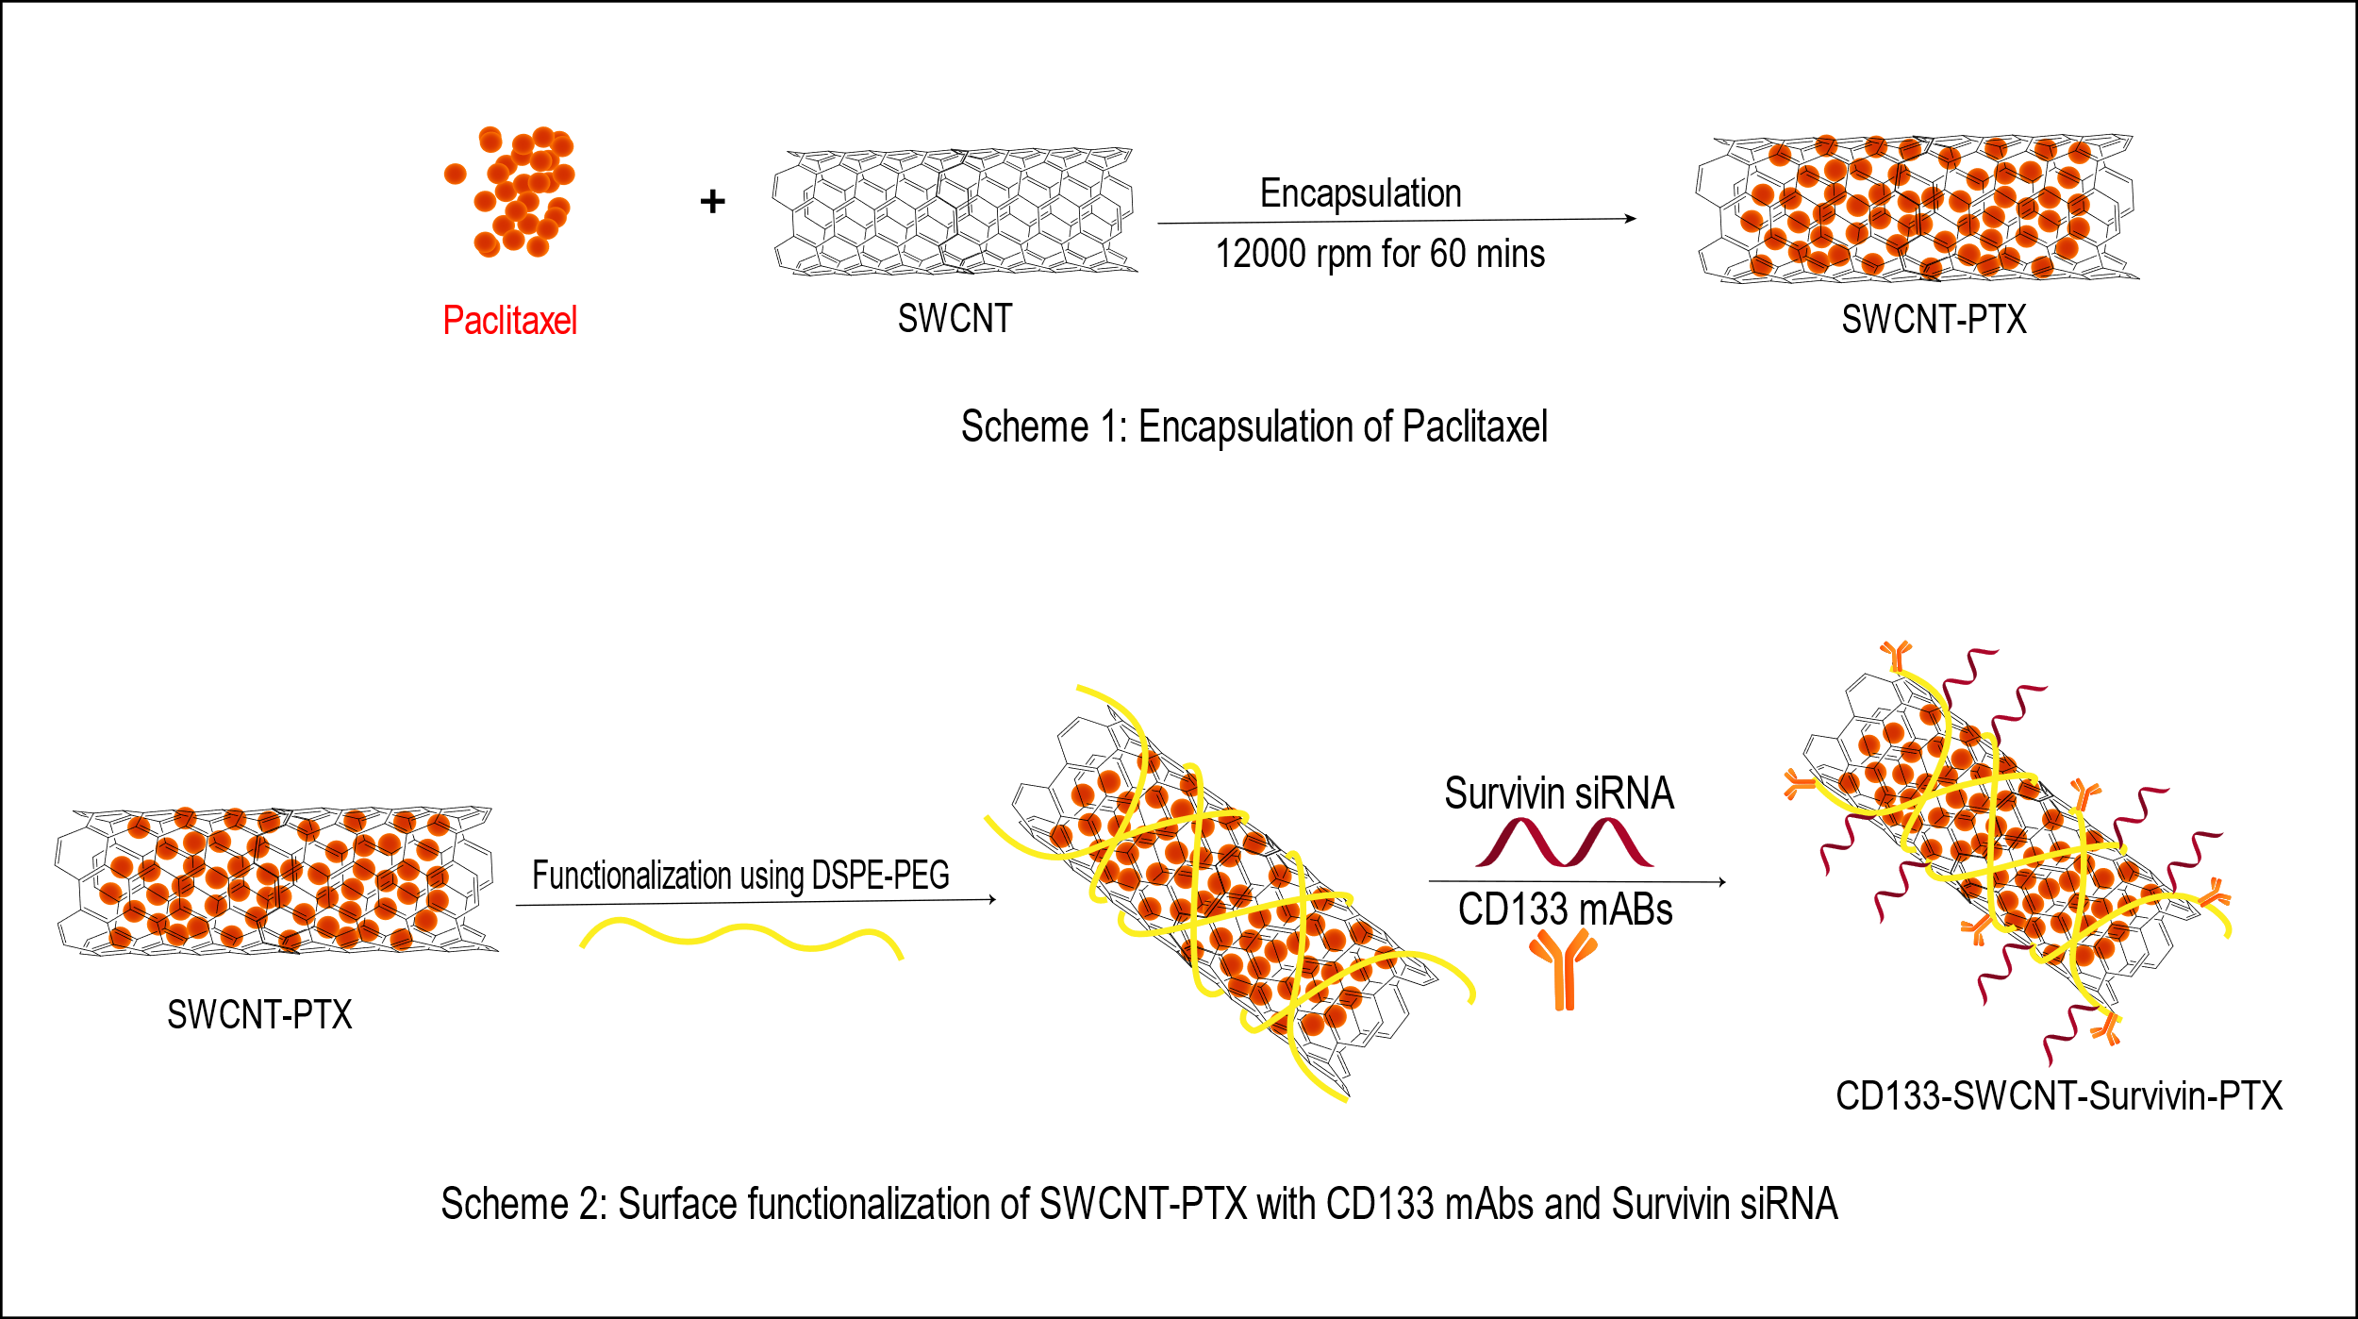

Figure 1. Synthesis of CD133-SWCNT-Survivin-PTX

In the present paper, an effort has been made, therefore, to develop CD133 mAb surface modified carbon nanotubes loaded with survivin siRNA and Paclitaxel (PTX) (CD133-SWCNT-Survivin-PTX) to achieve site specifically deliver of multiple drug cargoes to effectively treat NSCLC (see Fig 1). The developed formulation is expected to provide the following advantages over the existing treatment:

• Able to carry multiple drug cargoes consisting of antiapoptotic Bcl-2 gene siRNA, and chemotherapeutic agent.

• Can achieve site specific delivery of multiple drug cargoes to NSCLC through CD133 mAb directed against CD133 receptors present on NSCLCs

• Can reduce dose limiting and off-target side effects of Paclitaxel

References

1. Ammu VVV Ravi Kiran, Garikapati Kusuma Kumari, Praveen T Krishnamurthy, Renat R Khaydarov. Tumor microenvironment and nanotherapeutics: intruding the tumor fort. Biomater. Sci., 2021,9, pp.7667-7704

2. Ammu R.K., Kumari G.K., Praveen T. K., Khaydarov R.R. et al. Methods for enhancing dispersibility of carbon nanotubes, in "Emerging Applications of Carbon Nanotubes in Drug and Gene Delivery", 2023, Editor: Prashant Kesharwani, Woodhead Publishing, Elsevier, pp. 95-118

3. Ammu R.K., Kumari G.K., Praveen T. K., Khaydarov R.R. et al., Gene cargo delivery aspects of carbon nanotubes, in "Emerging Applications of Carbon Nanotubes in Drug and Gene Delivery", 2023, Elsevier, pp. 157-174