**PRODUCTION OF IRIDIUM-192 IONIZING RADIATION SOURCE FOR RADIOGRAPHIC TESTING OF METAL WELDED JOINTS**

*Ashrapov U.T.1, Sadikov I.I.,1 Malikov Sh.R.,1 Kamilov I.M.,1 Mogoch S.B.2*

1 Institute of Nuclear Physics of Uzbekistan Academy of Sciences (INP AS), Tashkent, Uzbekistan

2 «Daesen NDT International Engineering» LLC, Tashkent, Uzbekistan

The Institute of Nuclear Physics was developed a unique technology for producing highly active radionuclide 192Ir by irradiating natural iridium disks with thermal neutrons in the vertical channel of the WWR-SM reactor by nuclear reaction 191Ir(n, γ)192Ir. A closed source of ionizing radiation Ir-192 with an activity of 120 Ci was manufactured and it was equipped with a gamma flaw detector Gammarid 192/120M using special technology.

The manufactured source of Ir-192 is an import-substituting product and source together with Gammarid-192/120M is used for non-destructive quality control of welds of metal products.

Metal disks of natural iridium (∅=2.7 mm, h=0.2 mm, m=31.7 mg) in the amount of 20-30 pieces, packed in aluminum foil, were irradiated in the vertical channel of the reactor in the EK-20 block container inside the hollow cavity of a fuel assembly of the IRT-4M type with an enrichment 19.7%. The thermal neutron flux density was 0.9·1014 neutron/cm2 sec and the irradiation time was from 600 to 980 hours. In the “hot cells” of the reactor, packages with irradiated iridium disks were placed on a special device, and radiochemical treatment was carried out on the irradiated iridium disks (treatment with an alkali solution, water and drying). Next, the irradiated iridium disks in a magnetic stainless steel capsule were placed, the capsule was closed with a lid, and welding was carried out using argon arc spot welding. The tightness of the Ir-192 source by immersion method with immersion in an 10% aqueous solution of Н3РО4 acid was tested. In a protective chamber with manipulators by special installation, the Ir-192 source was placed into a source holder capsule, which was equipped with a lid and the holder with source was rolled up, then the holder with source was connected to a flexible shaft. The holder with the Ir-192 source was connected to the flexible shaft of the ampoule line and charged into the radiation head of Gammarid192/120M from depleted uranium.

Technical characteristics of the Gammarid 192/120M: Total weight of the set is 27 kg; Radiation head weight 16 kg; Control panel weight 9 kg; Distance from the manual drive to the emitting head is from 8 m to 16 m; Maximum movement of the encapsulated Ir-192 source horizontally is 2.0 m, vertically is 1.0 m; Optimal penetration thickness is 80 mm for steel, 250 mm for light materials. Technical characteristics of the source Ir-192: Activity is 120 Ci; External dimensions of the Ir-192 source: ∅=7.5 mm, h=10 mm; tightness of the source capsule - sealed with the level of radioactive contamination of the source not exceeding 185 Bq.

Since 2015, Gammarid 192/120M gamma flaw detectors with Ir-192 ionizing radiation sources have been widely and successfully used in the inspection of welded joints in the construction of a gas chemical complex, a gas processing plant, and in the construction of several thermal power plants in the energy industry in the Republic of Uzbekistan. Radiographic images using the gammagraphic control method were also evaluated by foreign partners working at these production facilities as a third party inspection and found to comply with the requirements of international standards ASME, EN, as well as GOST 7512-82, operating in the territory of the Republic of Uzbekistan. In Fig. 1 shows an X-ray image of one of the samples of pipeline welded joints obtained at the Syrdarya Thermal Power Plant (Shirin city) using gamma flaw detector Gammarid-192/120M with an Ir-192 source.

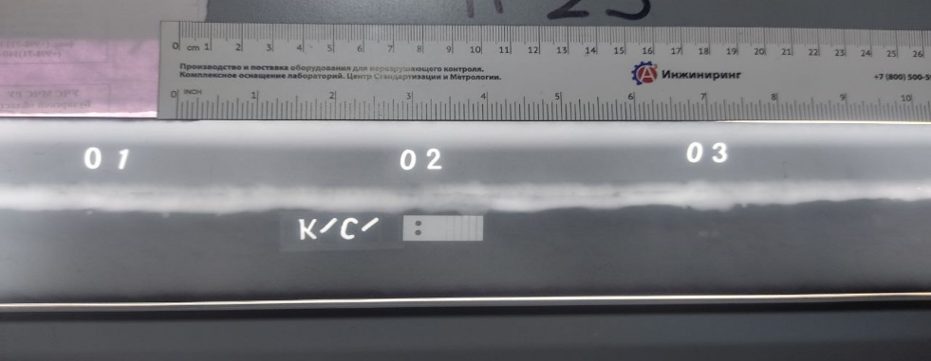

Fig.1. X-ray image of a weld sample, obtained using a method of gamma radiography with an Ir-192 source.

The following characteristics of the NDT image were obtained (Fig 1), which correspond to international standards: testing pipe Ø219x8mm, X-ray film Carestream (Kodak) Industrex AA400 NIF 30x40, cassettes with lead screens. NDT was made through two walls of pipe with a total thickness of 16 mm. Activity of radionuclide 192Ir is 60 Ci. The exposure time is 19 seconds. Optical density of the x-ray image is 2.5 and development time of film is 2 min. To assess the exposure dose rate of gamma radiation from the radionuclide Ir-192, as well as for dosimetric monitoring, the following were used: an individual dosimeter DKG-RM 1621, an individual thermoluminescent dosimeter DVG-02T, a dosimeter “Radiogem 2000”, a dosimeter DKS-04.

From Fig. 1 it is clear that the defects in the picture are no penetration at the root of the weld, slag inclusions.