**SYNTHESIS AND CHARACTERIZATION OF MINERAL MODIFIED POLY-N-VINYLPYRROLIDON-AGAROSE COMPOSITES FOR MEDICAL APPLICATION**

*Danko I.V., Beksultanov Zh.I., Bannych V.I., Mamytbekov G.K.*

Instituteof Nuclear Physics, Almaty, Republic of Kazakhstan

A systematic investigation was conducted to synthesize hybrid composite materials using synthetic poly-N-vinylpyrrolidone and natural (agar-agar) macromolecules with plasticizers (PEG-400) and mineral fillers such as shungite, bentonite and montmorillonite by electron irradiation.

The mechanism of formation of intercalated structures of mineral particles in the volume of a polymer matrix synthesized by electron irradiation of solutions of agarose and PVP polymer blends in the presence of PEG-400 as a plasticizer was proposed (Fig.1). The content of mineral filler was chosen to be equal to 0.5% by weight to obtain a uniform distribution of the shungite suspension in the volume of the polymer mixture solution while maintaining its aggregative stability.



Figure 1. Schematic diagram of the formation of hybrid composites P[PVP-AA-PEG]:{Sh}

The XRD and SEM data showed that the structure of the resulting hybrid composites is an interpenetrating network with distributed particles of mineral components. It has been established that the mechanical properties of hybrid composites are determined mainly by the structural organization of the interpenetrating polymer network formed under electron irradiation of the initial synthetic and natural polymer mixture in the presence of plasticizers, as well as by the conditions for intercalation of polymer segments into the mineral matrix and vice versa. It has been revealed that the degree of swelling of hybrid composites strongly depends on the concentration of a low-molecular plasticizer in the polymeric interpenetrating network, which easily impregnates into the matrix of shungite (Fig.2).

|  |  |
| --- | --- |
| C:\Users\Home\Desktop\IPHONE\IMG_5155.jpg  **a** | C:\Users\Home\Desktop\IPHONE\фото\реология\IMG_4859.JPG C:\Users\Home\Desktop\IPHONE\фото\реология\IMG_4869.JPG  **b** |
| Figure 2. Images of the development of crazing in [PVP-AA-PEG]:{Sh-125} at stretching (a) and pushing of the ball (b) hrough a layer of the composite | |

Successfully obtaining destructive radiation cross-linking of [PVP-AA-PEG] hydrogels with shungite can be applied in regenerative medicine as wound healing dressings (Fig. 3).

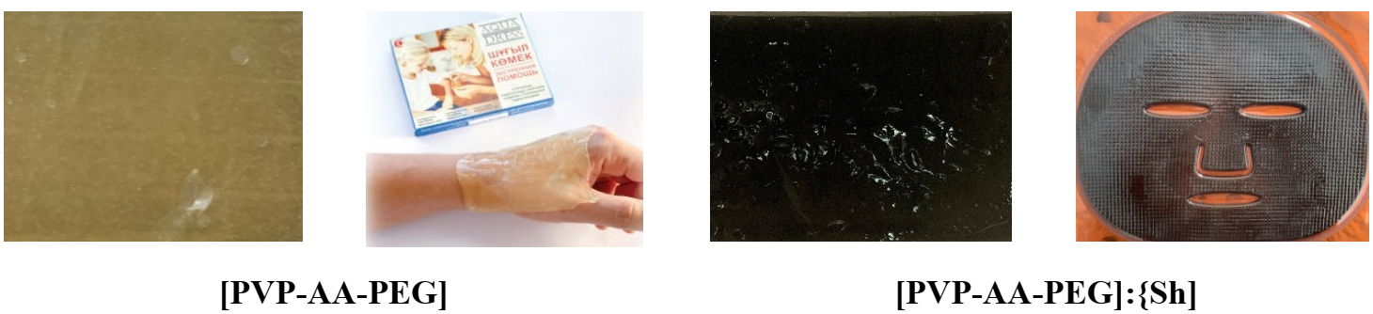

Figure 3. Some aspects of the use of polymer hydrogel compositions in medicine and cosmetology

The resulting hydrogel dressings create a moist environment at the wound site that is optimal for the normal course of regeneration processes of damaged tissue. Such therapeutic tactics are currently used in reconstructive surgery of wounds, as a moist environment accelerates the process of proliferation of cellular structures, restores the water balance and improves the transport of nutrients in tissues affected by thermal factors.