**Study of total cross sections for the reactions 10,11,12Be+28Si**

Naumenko M.A.1, Samarin V.V.1,2, Sobolev Yu.G.1, Stukalov S.S.1,3, Penionzhkevich Yu.E.1,4

*1 Flerov Laboratory of Nuclear Reactions, Joint Institute for Nuclear Research, Dubna, Russia*

*2 Department of Nuclear Physics, Dubna State University, Dubna, Russia*

*3 Department of Nuclear Physics, Voronezh State University, Voronezh, Russia*

*4 Department of Experimental Methods in Nuclear Physics, National Research Nuclear University, Moscow, Russia*

E-mail: anaumenko@jinr.ru

The study of the total cross sections for the reactions involving neutron-rich weakly bound nuclei at low and intermediate energies makes it possible to obtain information on their structure (halo, skin, effective matter radii) and its manifestation in nuclear reactions [1, 2].

In this work, we measured the total reaction cross sections for the 10,11,12Be nuclei on the 28Si target by the 4π method based on the registration of the prompt γ quanta and neutrons accompanying the interaction using the multidetector spectrometer. The procedure of processing of the obtained experimental data was based on taking into account the probability distribution of the number of triggered spectrometer detectors [3]. The obtained results are shown in Fig. 1 in comparison with the data from other studies and empirical Kox parametrization [4].

Based on the measured values of the total reaction cross sections and the phenomenological optical model, the effective matter radii of the 10,11,12Be nuclei were determined. A new approach based on the combination of the optical model with the modified optical potential and classical trajectories was applied to the calculations of the effective matter radii of the colliding nuclei (details are given in [3]).

The total reaction cross sections for the 11Be nuclei are significantly larger than those for 10Be. Along with the low value of the neutron separation energy (0.5 MeV) for 11Be, it is an indication of its halo structure. The total reaction cross sections for the 12Be nuclei are larger than those for 10Be. Along with the pairing of two outer neutrons and the larger value of the neutron separation energy (3.2 MeV) for 12Be, it is an indication of its more compact outer shell (compared to a halo) which can be called a skin.

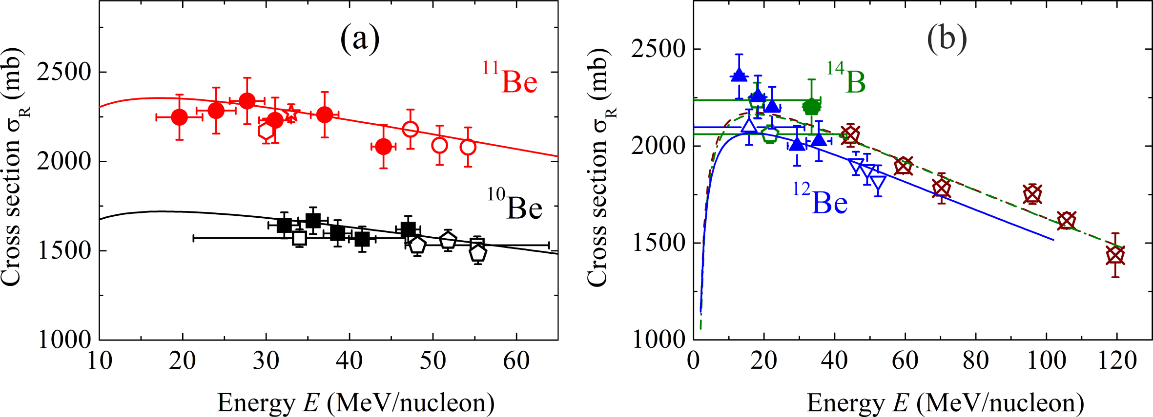

**Fig. 1.** Experimental total cross sections for the reactions (a) 10Be+28Si: filled circles (this work [3]), empty squares*, and pentagons*; 11Be+28Si: filled circles (this work [3]), empty circles*, and hexagon*; 11Be+27Al: star*; (b) 12Be+28Si: filled triangles (this work [3]), empty triangle up*, and empty triangles down*; 14B+28Si: filled pentagon (this work [3]) and empty pentagons*; 14B+27Al: crossed pentagons*. Curves of the corresponding color are the result of the empirical Kox parametrization [4]. *References to these works are given in [3].

The work was supported by the Russian Science Foundation, Grant No. 24-22-00117.

**References**

1. Yu. E. Penionzhkevich, Phys. At. Nucl. **74**, 1615 (2011).
2. Yu. E. Penionzhkevich and R. G. Kalpakchieva, *Light Exotic Nuclei Near the Boundary of Neutron Stability* (World Scientific, Singapore, 2021).
3. Yu. G. Sobolev, V. V. Samarin, Yu. E. Penionzhkevich, S. S. Stukalov, and M. A. Naumenko, Phys. Rev. C **110**, 014609 (2024).
4. S. Kox, A. Gamp, R Cherkaoui, A. J. Cole, L. Longequeue, J. Menet, C. Perrin, and J. B. Viano, Nucl. Phys. A **420**, 162 (1984).